Exp. No: 2 Determination and plotting of Electric field and Electric flux density in sphere full of charges with varying radius.

Aim:
To write program for electric field and electric flux density in sphere using SCILAB.

Software required:
•SCILAB version 6.0.1
Theory:
Program:
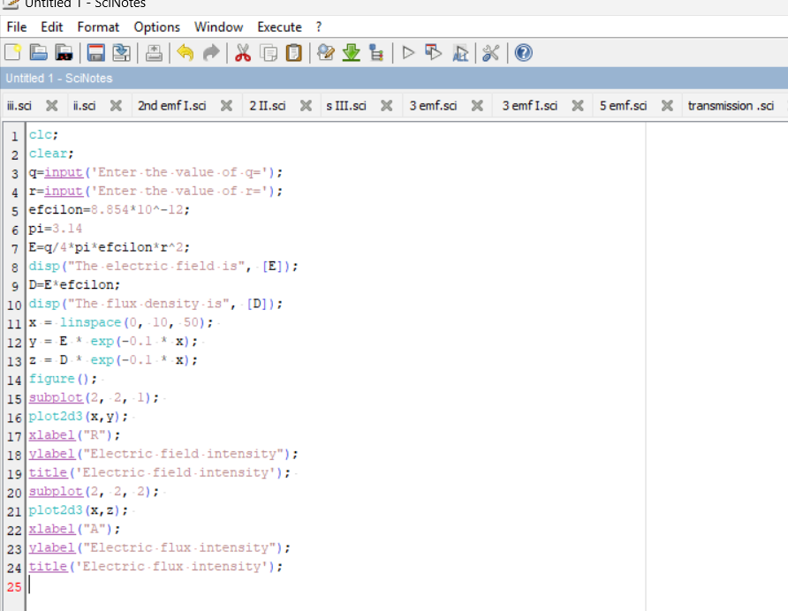

Output:
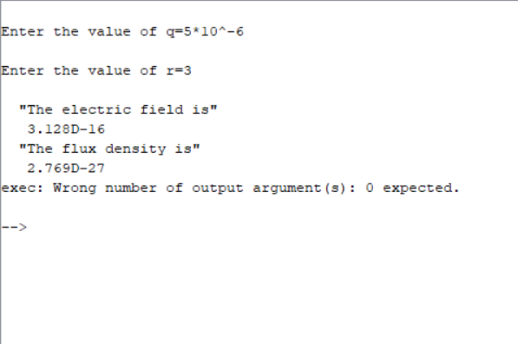
Graph:
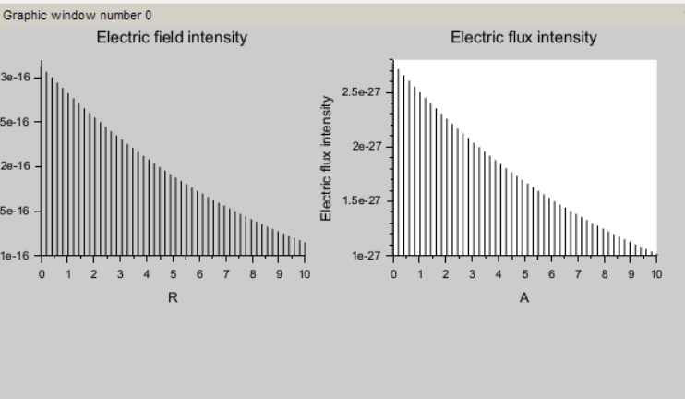

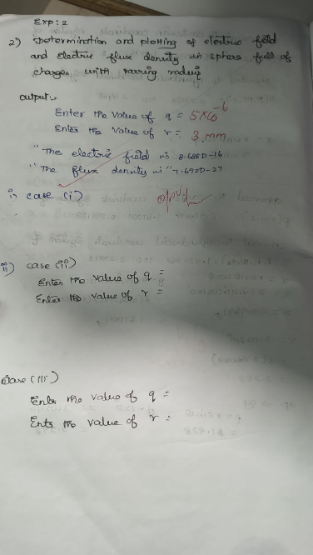

Case 1:
Derive and plot the electric field (E) and electric flux density (D) inside a uniformly charged sphere with charge density ρ0. What are the values of E and D at the center and at the surface of the sphere?

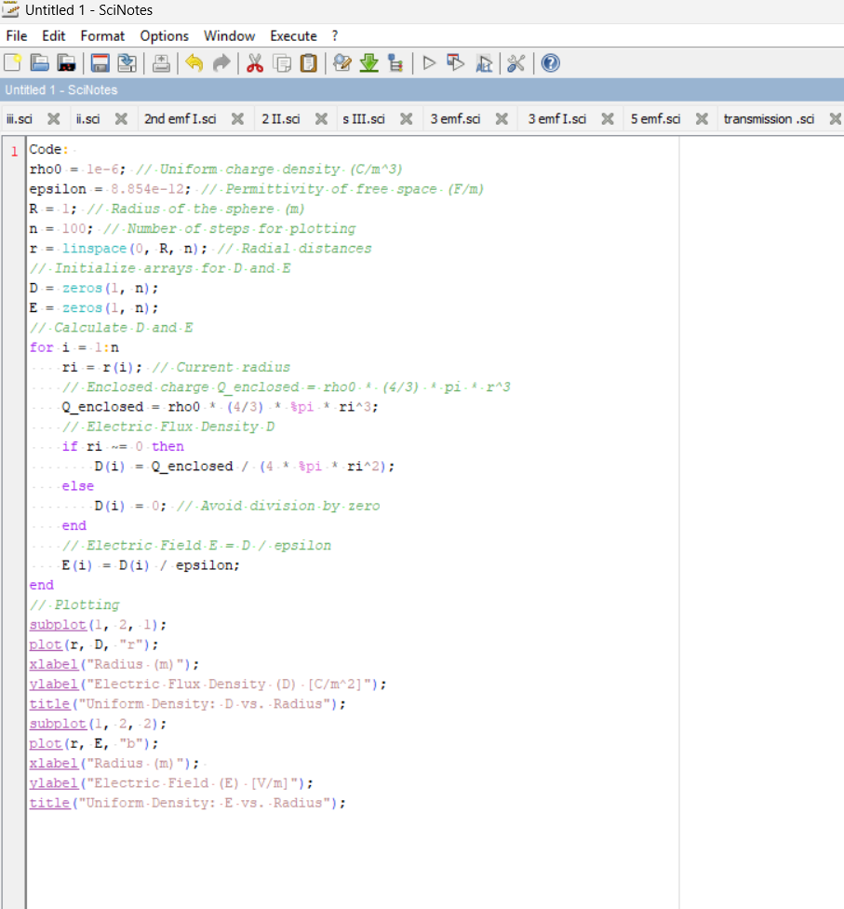Output:
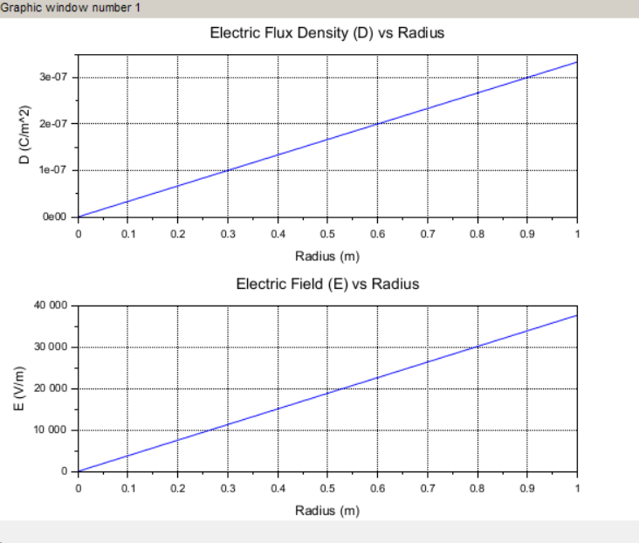

Case 2:
For a sphere with a linearly increasing charge density ρv=ρ0r.derive the expressions for the electric field (E) and electric flux density (D). Plot their variations inside the sphere and analyze the trends.
Code:
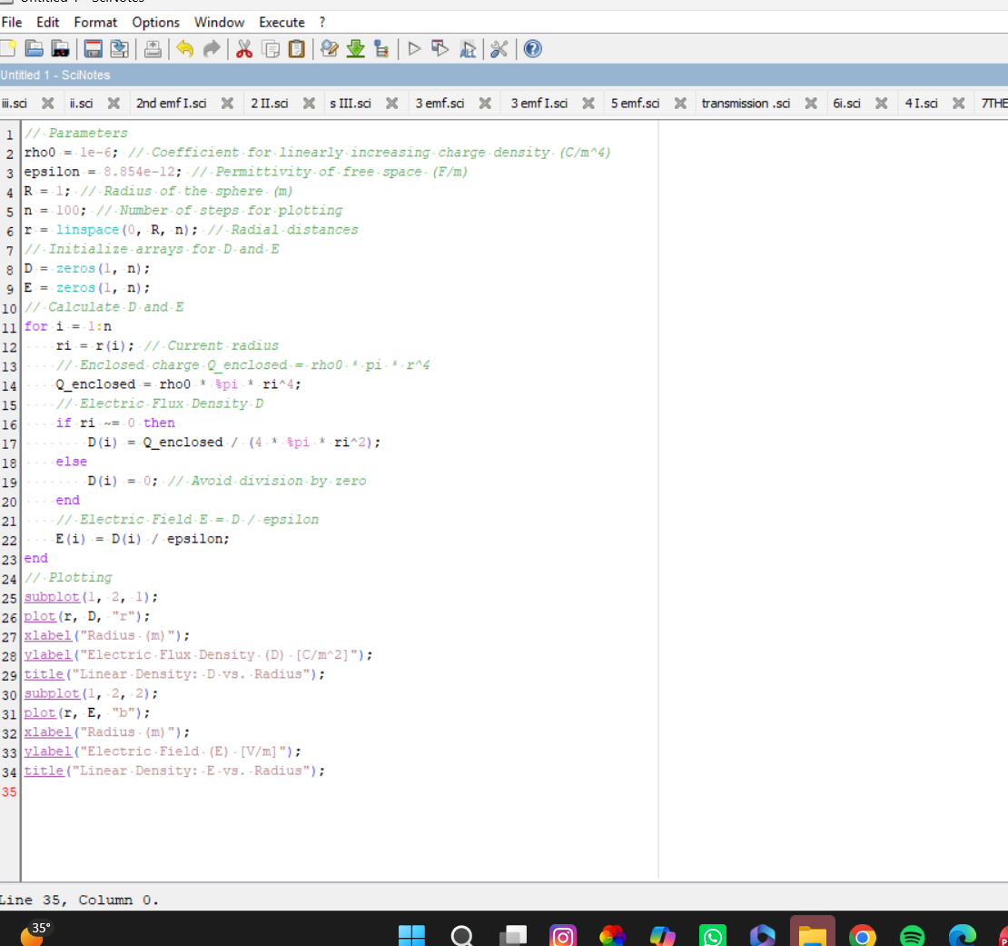

Output:
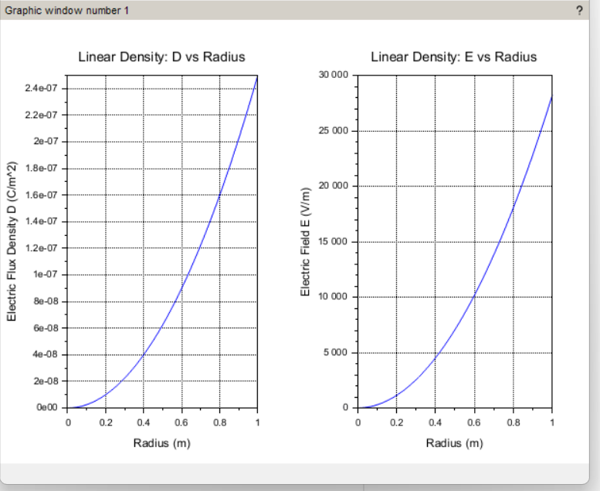

Case 3:
A sphere of radius R=2 m has a uniform charge density ρ=3×10^−6 C/m^3\
- Calculate and plot the electric flux density D(r) and electric field E(r) as a function of radial distance r, ranging from 0 to 4 meters.
- Discuss the behaviour of the electric field inside and outside the sphere.
Code:
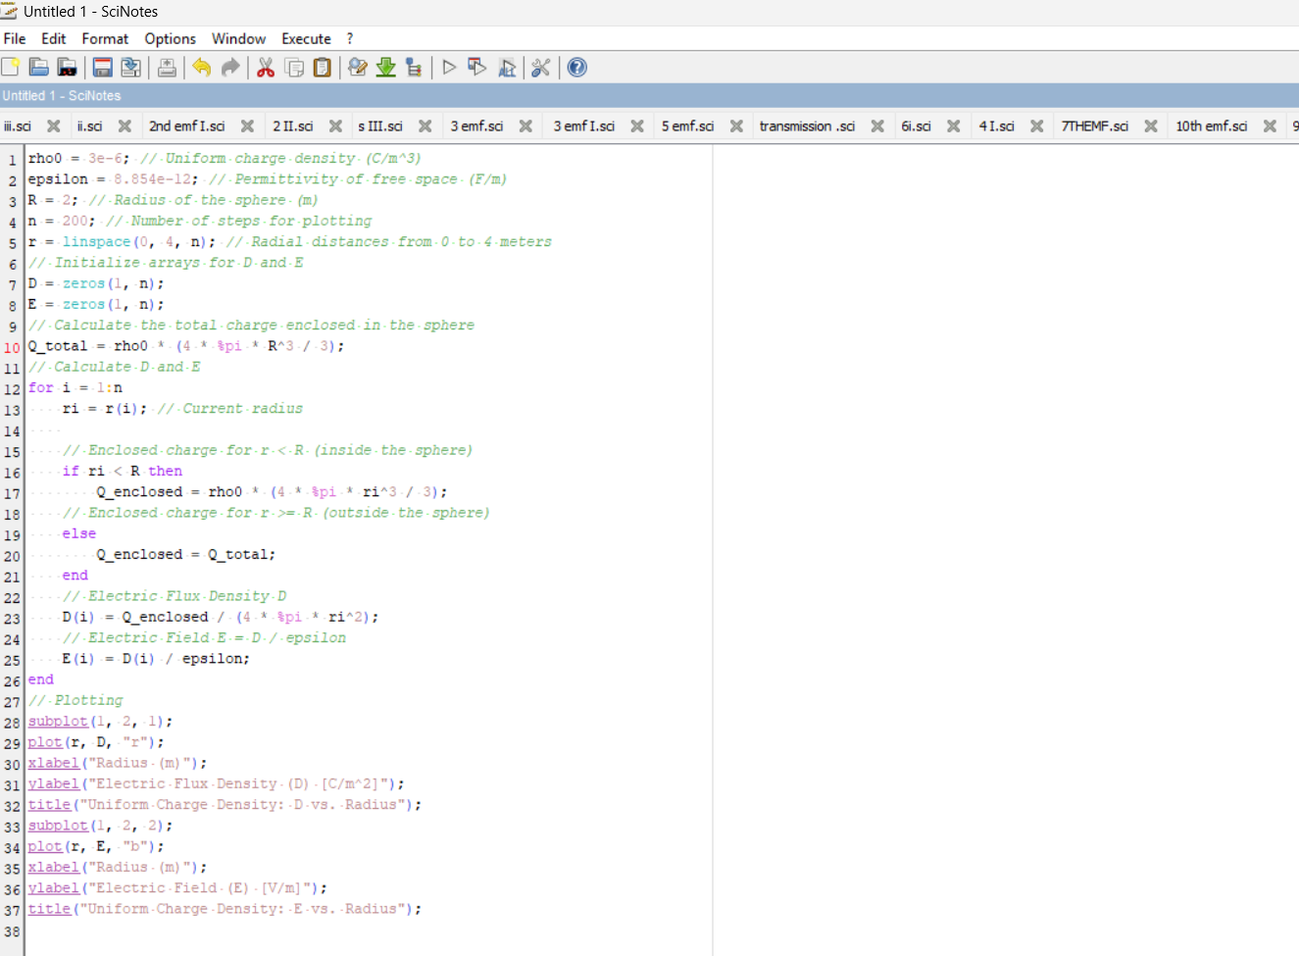Output:
